## UI / Wireframe Design using Figma ([Link](https://www.figma.com/proto/ywa3dInVTkc32zUgdc7nvu/Telemedicine--?node-id=1-25&p=f&t=KQvPcl9liY1PKr4Q-1&scaling=min-zoom&content-scaling=fixed&page-id=0%3A1&starting-point-node-id=1%3A2))

Figure : Landing page

Figure : Doctor Page

Figure : Medicine Page

Figure : Lab tests

Figure : Sitter Page

Figure : Pricing Page

Figure : Doctor Appointment

Figure : Medicine shipping page

Figure : Lab test confirmation page

Figure : SignUp Page

Figure : SignUp as patient

Figure : Successful message (auto redirect to portal)

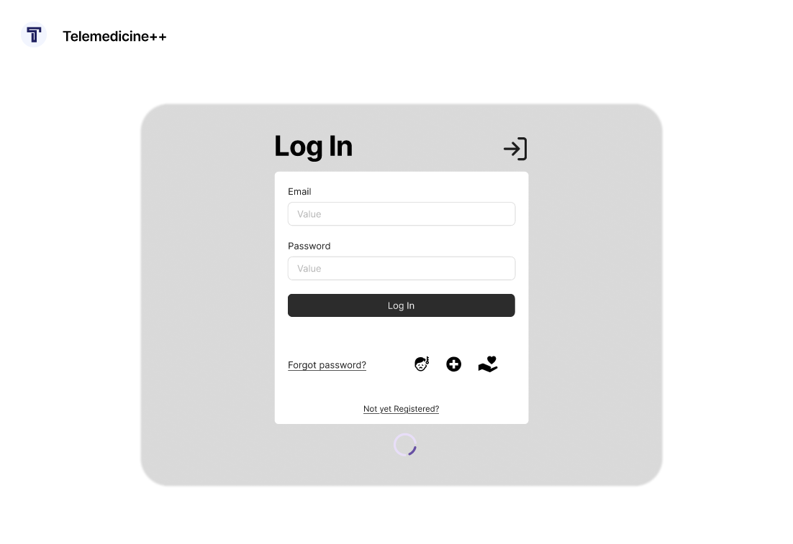

Figure : Log In page

Figure : Patient Dashboard

Figure : Live Transcribe option

Figure : Voice Assistant Option

Figure : Go Live option in appointments

Figure : Manage previous prescriptions

Figure : Doctor Dashhboard

Figure : Edit Profile option

Figure : Sitter Dashboard

Figure : Manage Appointments in sitter portal

Figure : Availability Status set option